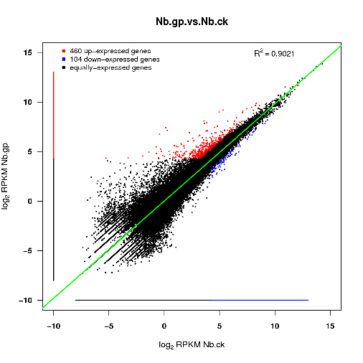
Supplementary Figure 1. The scatter plot of different expressed genes after GP-1 treatment. Points in the figure represent individual genes, in whichthe blue ones indicate down-expressed genes, the red ones indicate up-expressed genes, and the black ones indicate no significant differential genes.

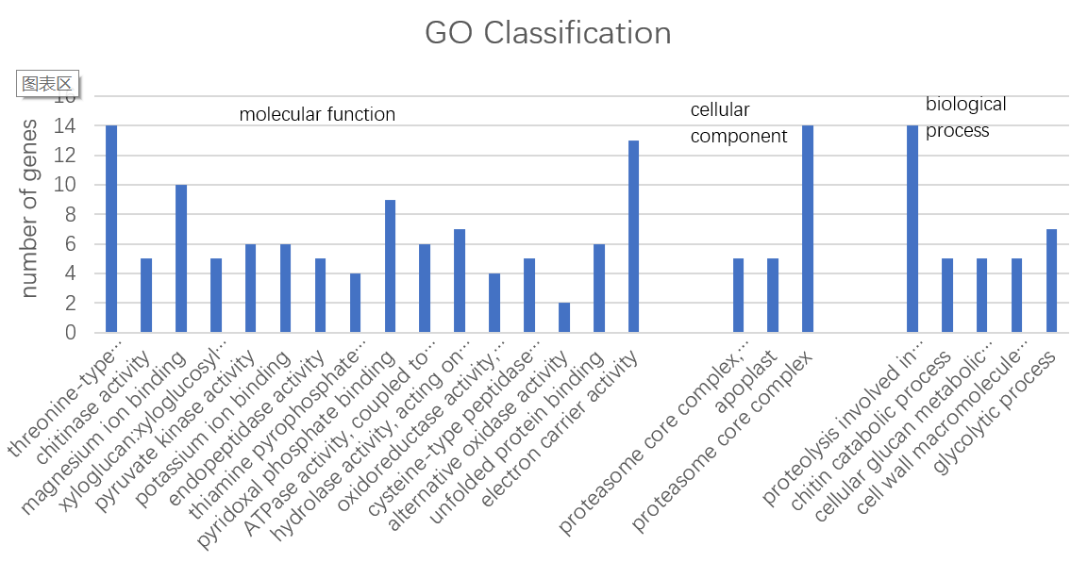
Supplementary Figure 2. The results of GO enrichment analysis of different expressed genes between GP-1 treated N. benthamiana and the control.
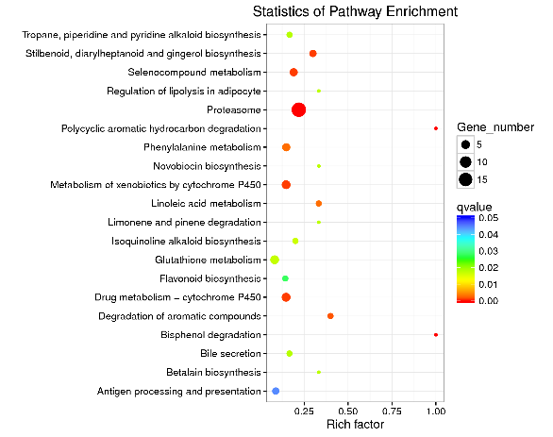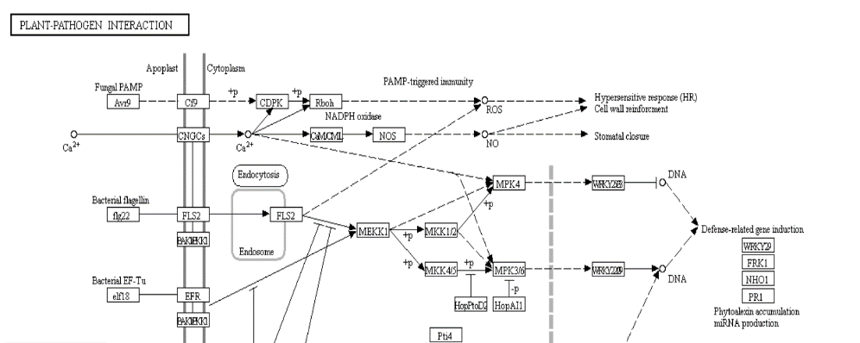
Supplementary Figure3. KEGG pathway enrichment analysis of GP-1 on N. benthamiana showing enriched pathways (a) and typical plant-pathogen interaction pathway (b).

